**OS lab assignment 1**

**Agnim Gupta**

**2028082**

**Question 1**

**Pwd:** **Shows Address**

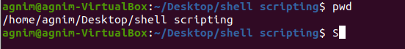

**Whoami**



**Mkdir**

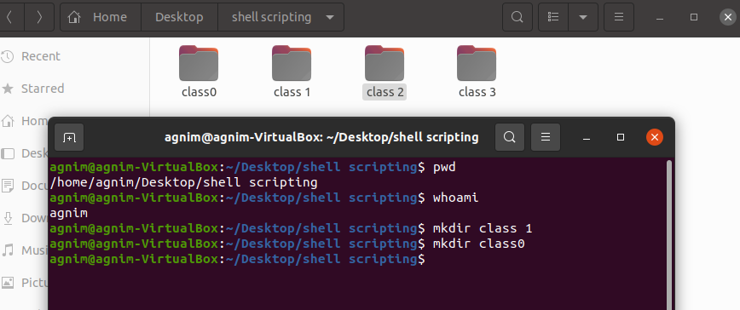

**Cp:** **To copy a directory including all content from directory to destination directory.**



**Rm: Delete a file**



**Rm -r: Delete a directory with contents**

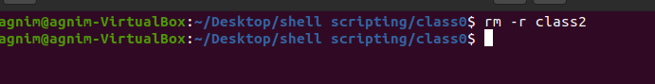

**Rmdir: Delete Empty directory**

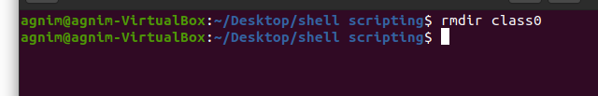

**Chmod: Change the permissions**

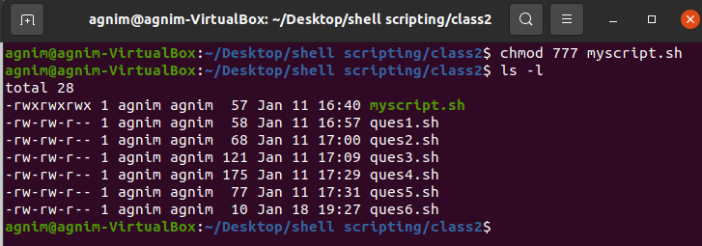

**Mv : Rename the file**



**Cat: Read the file**

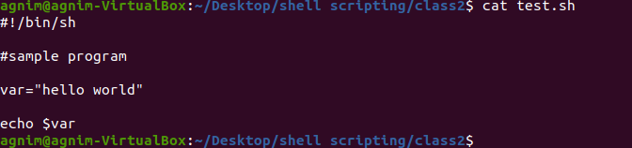

**Cat> : Write something inside a file**

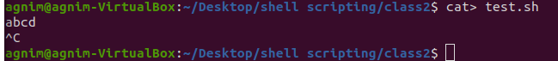

**Cat>>: Write again**

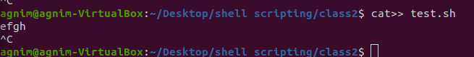

**Head:**



**Tail:**

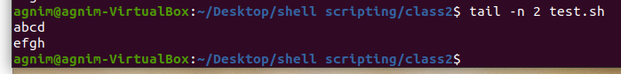

**Ln:** **Syntax: ln -s source_filename my_link.txt**

**ls -l my_link.txt**

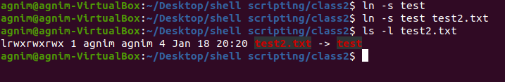

**Nl: To display what is written inside a file in point wise**

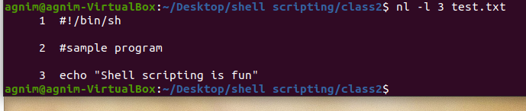

**Grep:**

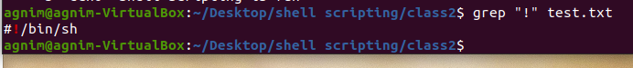

**Cut**

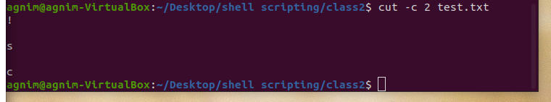

**Echo**



**Set: Without any argument, the set command lists all the shells variables, including their values.**

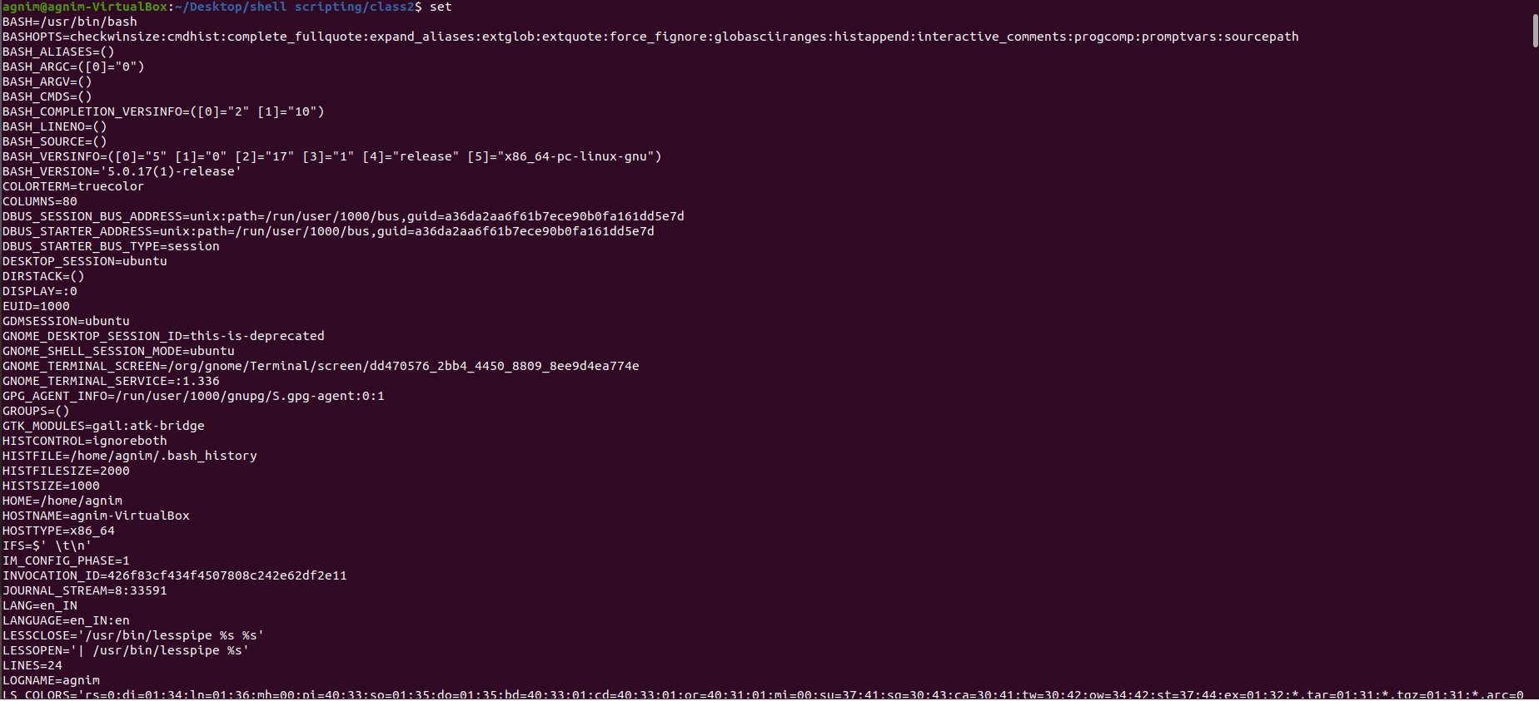

**Is**

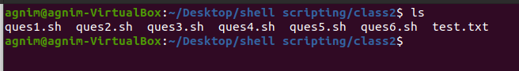

**Date**

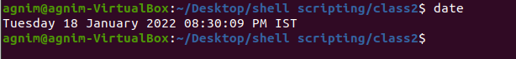

**More**

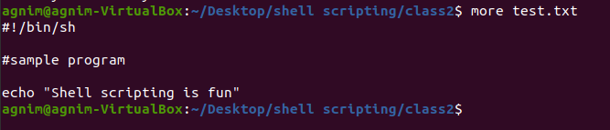

**Wc**



**History**

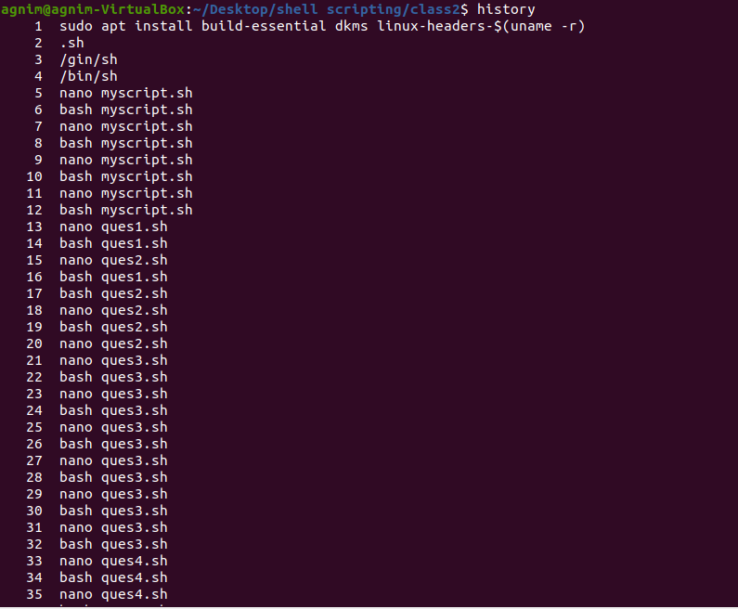

**Sudo**

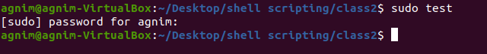

**Apt-get**

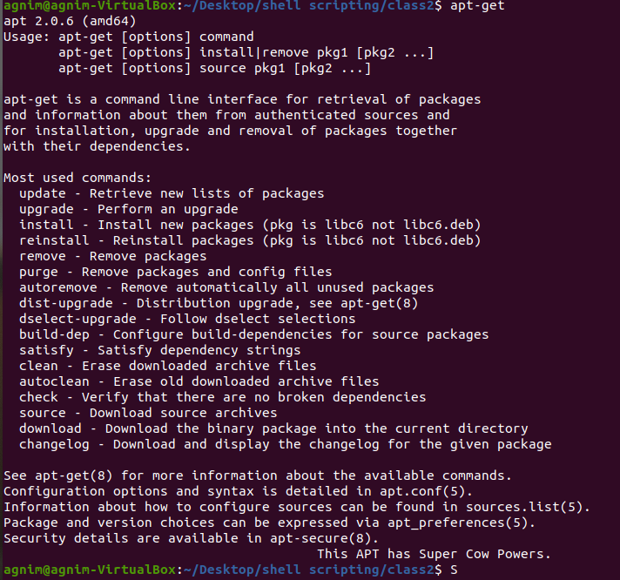

**Mail**

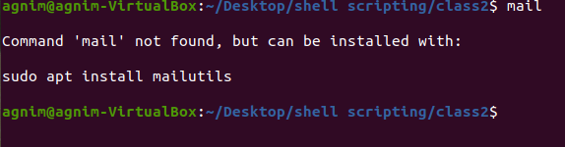

**Question 2**

**Vi**

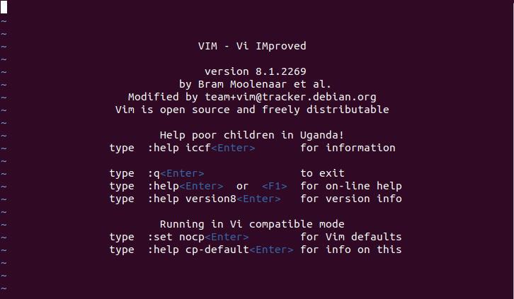

**Nano**

